Social Media Toolkit: Provincial Health Orders for Fraser Health
The Provincial Health Officer has issued a new Public Health Order for people living in the Fraser Health and Vancouver Coastal Health regions. The orders focus on four areas: social gatherings, travel, indoor group physical activities and workplace safety. These orders are in effect until November 23, 2020. You can learn more about these new orders here. Further information will also be available on our website soon.
Thank you for helping us get the word out to your networks and stakeholders. We have created this social media toolkit for your consideration.

- New orders from the Provincial Health Officer are in place. Right now, using your COVID sense means limiting your social interactions to your immediate household. Learn more: fraserhealth.ca/covidsense (2-Provincial-Health-Officer-Orders.jpg)

- New orders from the Provincial Health Officer are now in place. Learn more: https://www2.gov.bc.ca/gov/content/safety/emergency-preparedness-response-recovery/covid-19-provincial-support/lower-mainland (1-Provincial-Health-Officer-Orders.jpg)

- At this critical time, people in the Fraser Health region must pause all social gatherings of any size outside of our immediate household groups. For translated resources, visit: https://www.fraserhealth.ca/health-topics-a-to-z/coronavirus/resources#.X6l_9bqWyuU (1-Hindi.jpg, 1-Punjabi.jpg, 1-Chinese.jpg, 1-Korean.jpg, 1-Persian.jpg)

- Right now, using your COVID sense means limiting your social gatherings to your immediate household. Learn more: fraserhealth.ca/covidsense (2-Hindi.jpg, 2-Punjabi.jpg, 2-Chinese.jpg, 2-Korean.jpg, 2-Persian.jpg)

Instagram Images:
1-Provincial-Health-Officer-Orders.jpg
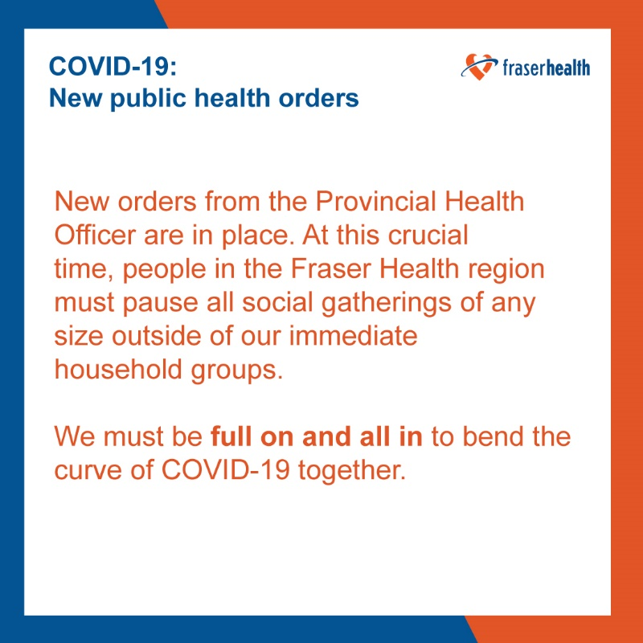
2-Provincial-Health-Officer-Orders.jpg
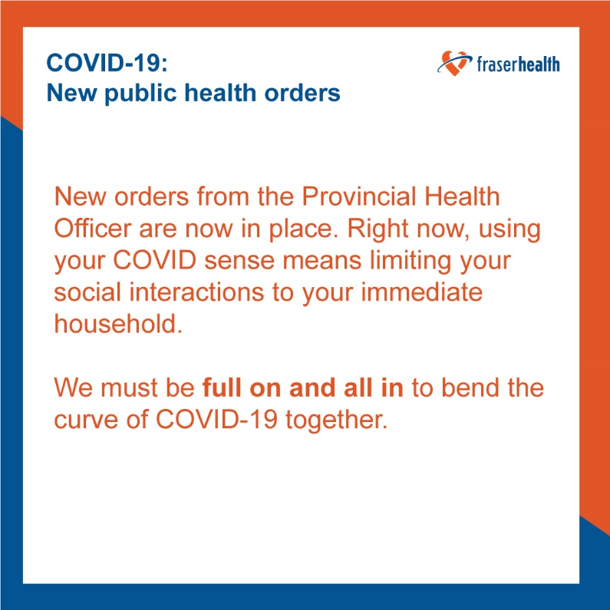

1-Hindi.jpg
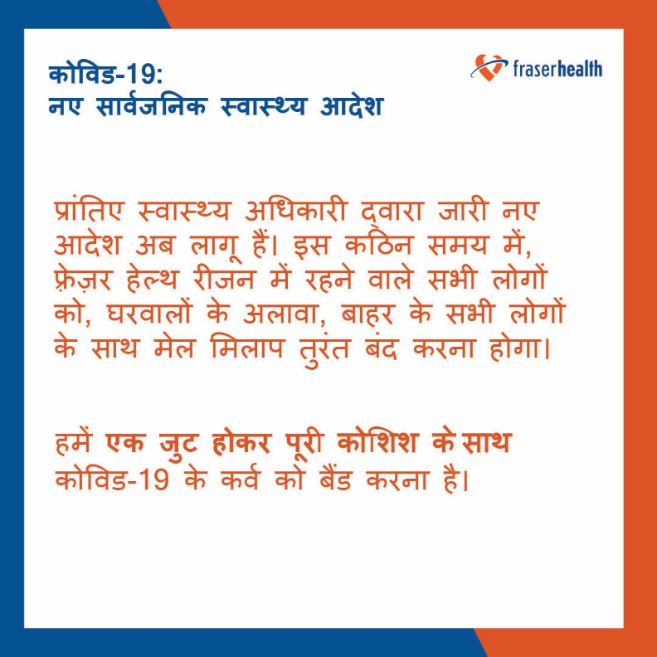
2-Hindi.jpg
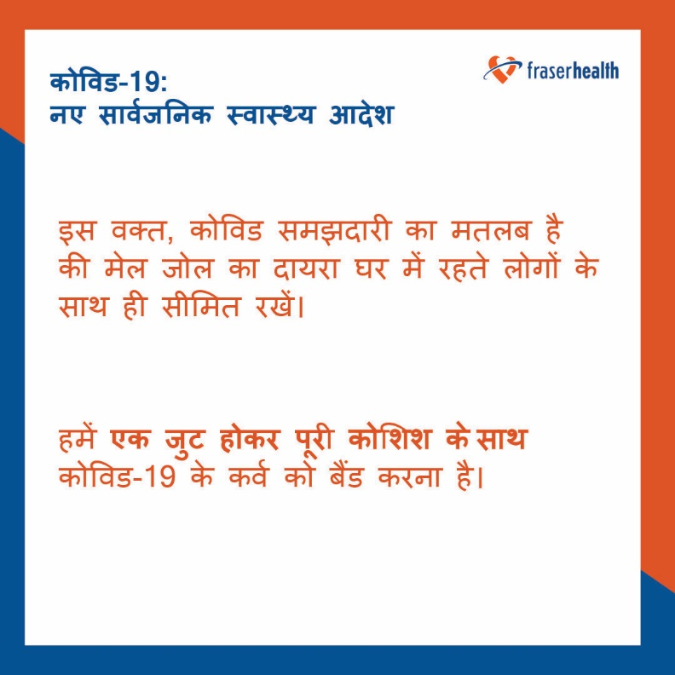

1-Punjabi.jpg
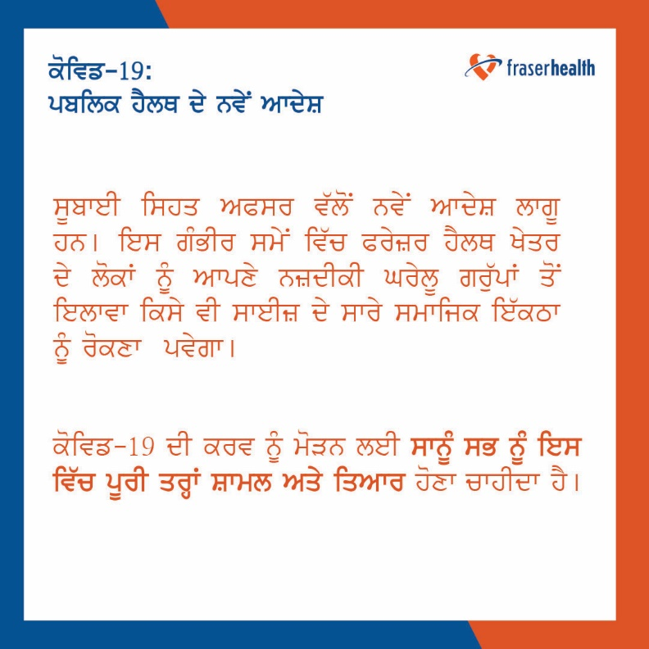
2-Punjabi.jpg
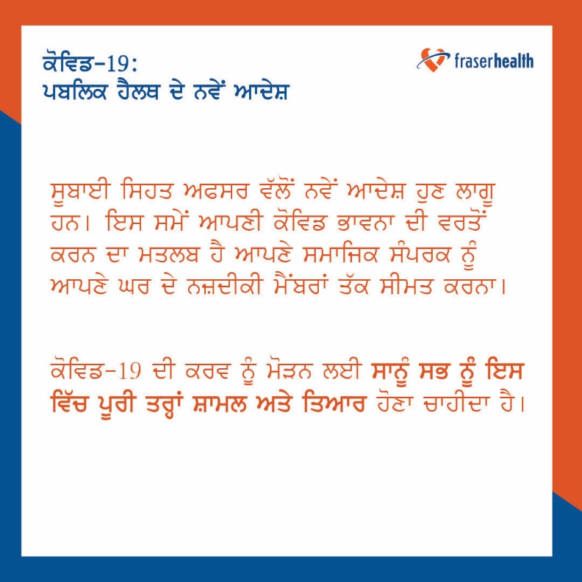

1-Chinese.jpg
2-Chinese.jpg

1-Korean.jpg
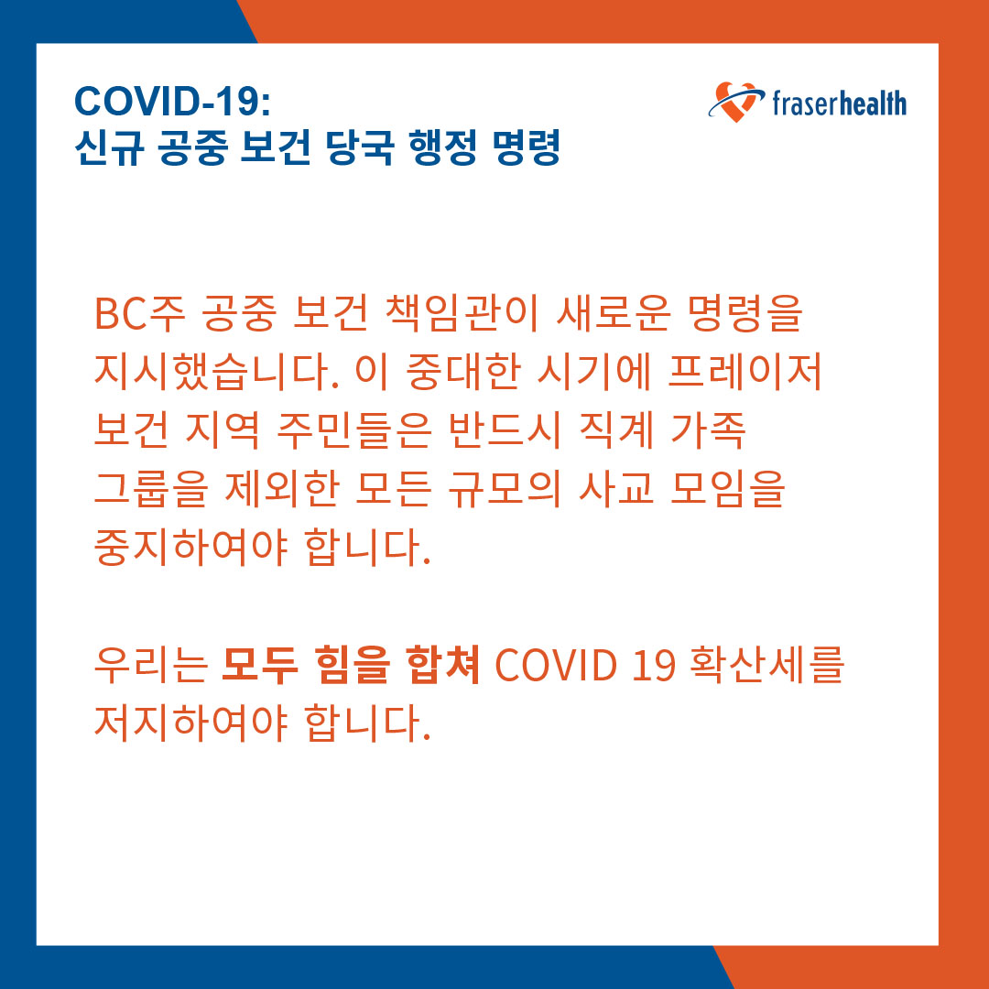
2-Korean.jpg
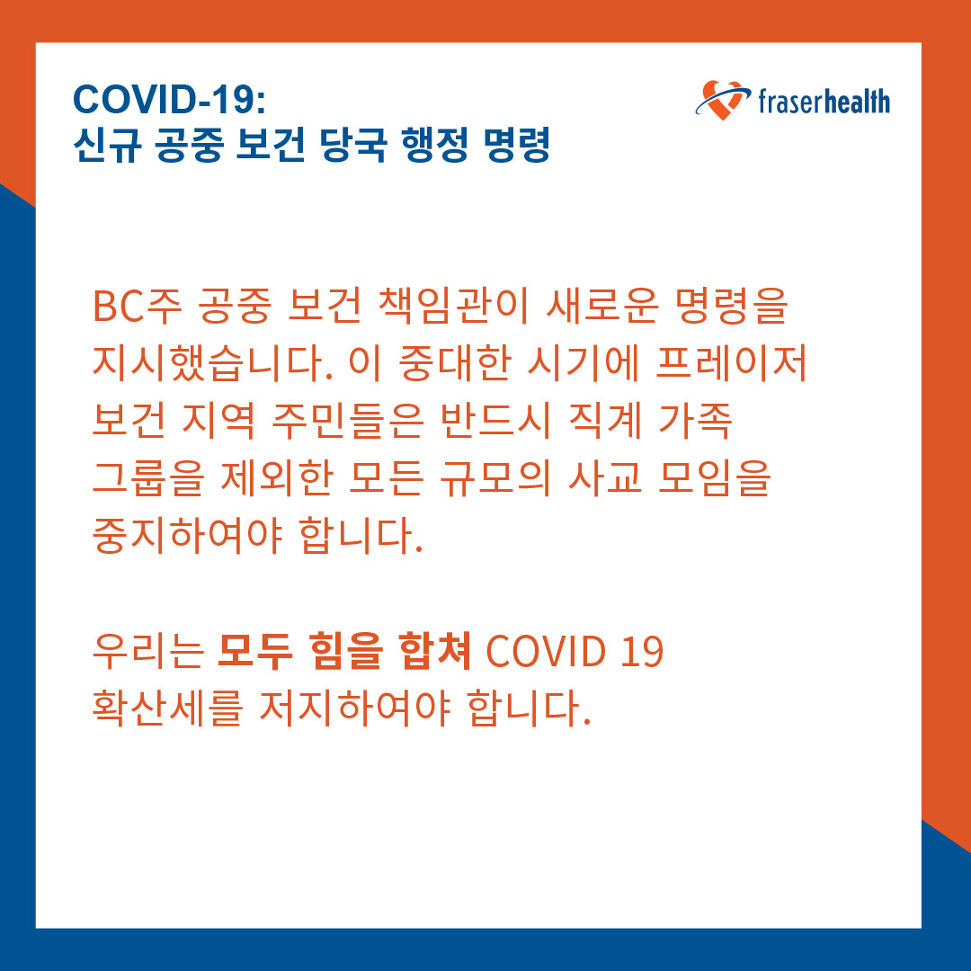

1-Persian.jpg
2-Persian.jpg

Facebook and Twitter Images:
1-Provincial-Health-Officer-Orders.jpg
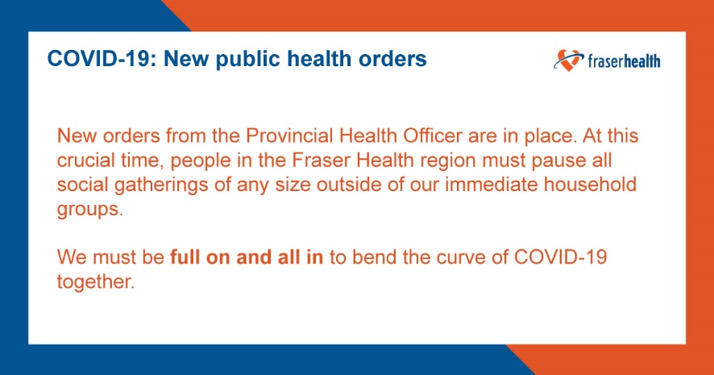
2-Provincial-Health-Officer-Orders.jpg
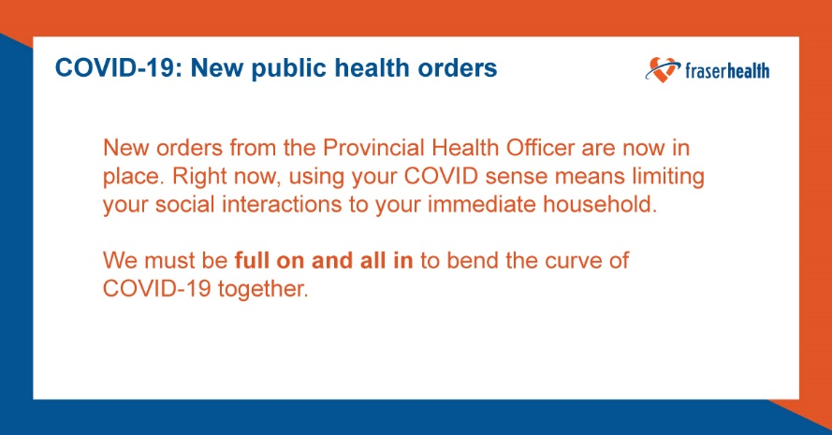
1-Hindi.jpg
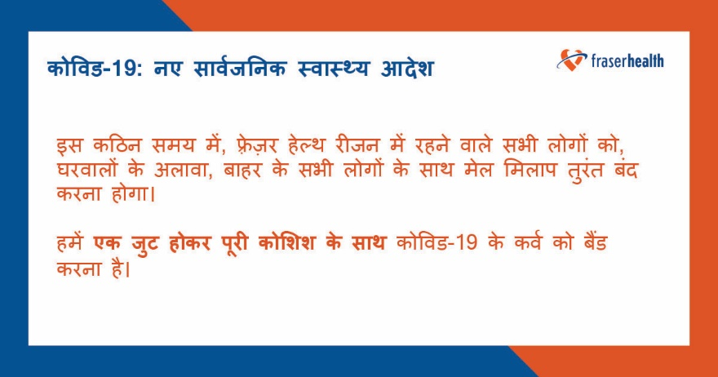

2-Hindi.jpg
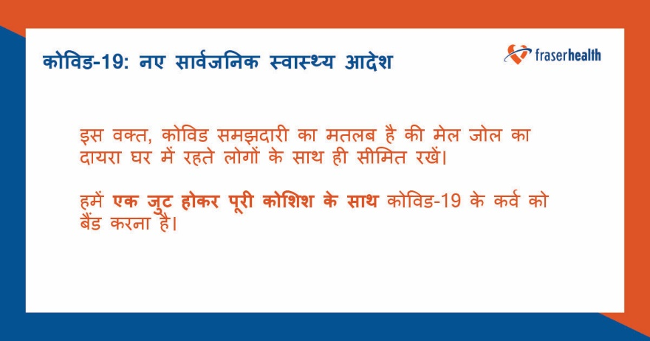
1-Punjabi.jpg
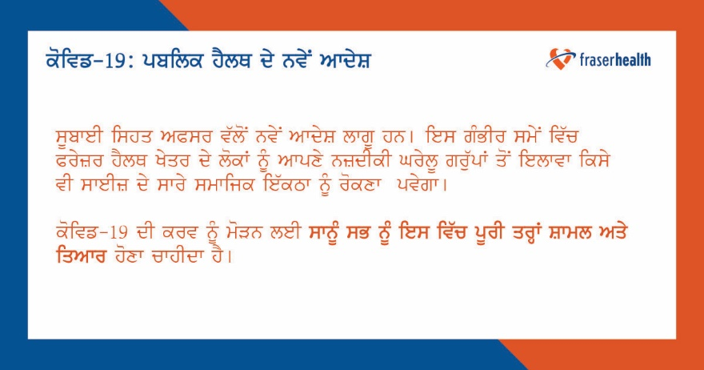
2-Punjabi.jpg
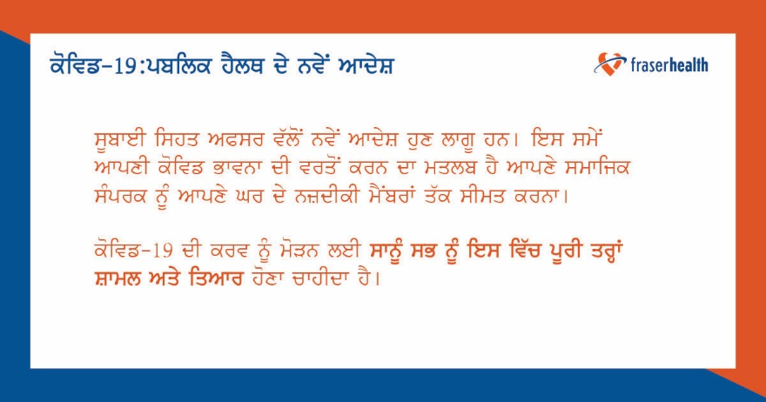

1-Chinese.jpg
2-Chinese.jpg
1-Korean.jpg
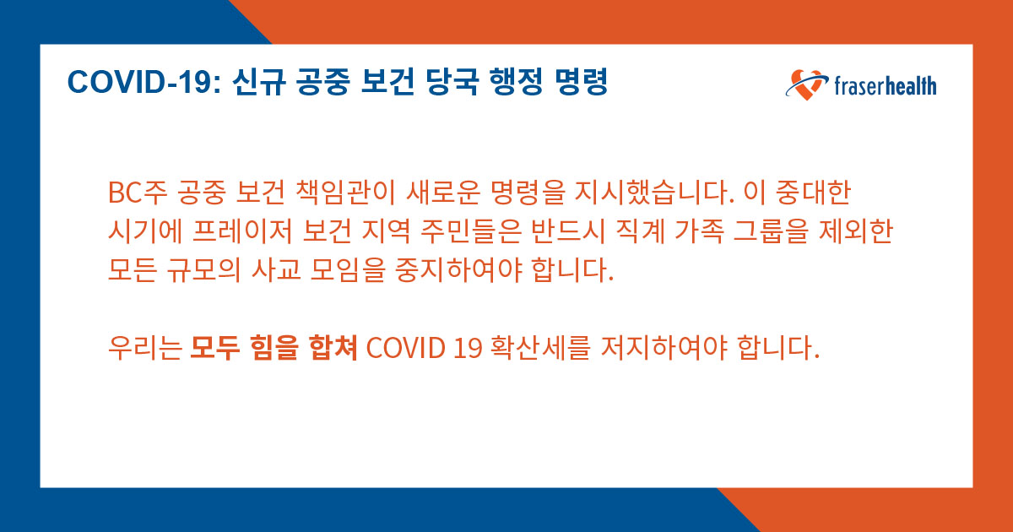

2-Korean.jpg

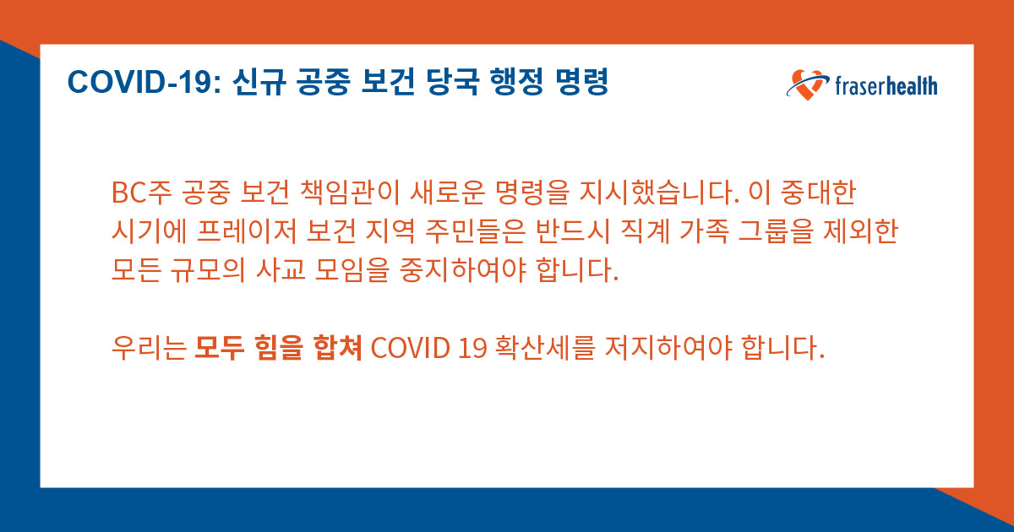
1-Persian.jpg
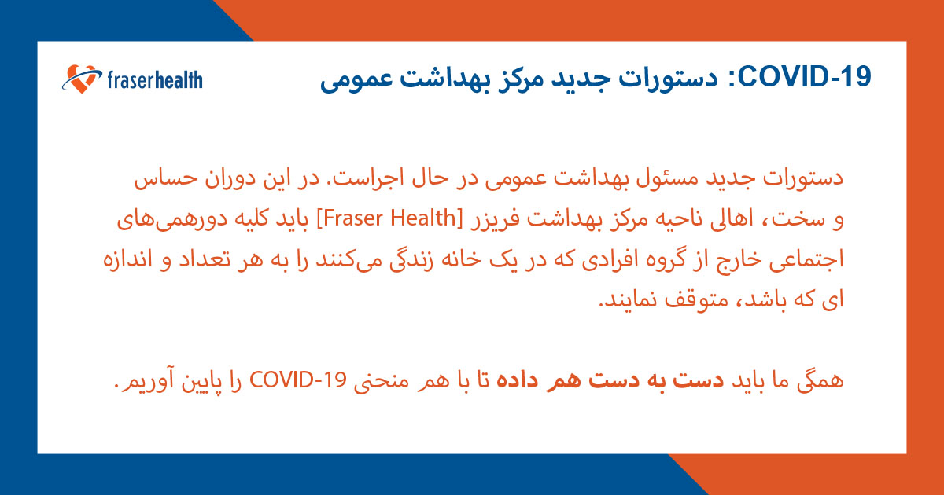
2-Persian.jpg
